The entire document must be written in 12-point Times New Roman font with 1.5-line spacing

Title (maximum 150 characters, including spaces)

Abstract
The abstract should be a single-paragraph summary of the most relevant aspects of the manuscript: introduction, objectives, methodology, results, and conclusions. It must not include discussion, citations, table references, or figures. The maximum length is 200 words for scientific articles and 150 words for essays.
Keywords: This is a list of three to five keywords, either single or compound, separated by commas and not included in the title.

Introduction

This section should present the problem related to the subject of study, as well as the state of the art, its relevance, originality, significance, the bibliographic background, the objectives, and the hypothesis of the work. In other words, the problem to be addressed must be precisely justified, avoiding generalities.
The background information must be based on relevant and recent scientific literature (at least 80 % of the citations should be no older than 10 years). The objectives must clearly specify and define the purpose and scope of the study; they should also be stated at the end of this section, match those presented in the abstract, and be consistent with the methodology and conclusions.

Methodological approach

This section should describe the most relevant and distinctive aspects of the study, providing sufficient detail to allow other researchers to replicate the work and verify the results. It must include the dates and locations of the study (with geographic coordinates and altitude), the factors and levels under research, schemes, variables evaluated along with their units and methods of measurement, materials and techniques used, as well as experimental management, procedures, and statistical analysis methods (qualitative or quantitative). In cases where extensive methodologies are followed and can be found in manuals or specialized publications, the corresponding citation must be included. Any modifications to established or generalized methods must be explicitly stated.

Results and discussion

This section should consist of the results obtained or observations made as a result of the applied methodology, and must be presented in an orderly, complete, and concise manner. Tables and figures (e.g., diagrams, graphs, photographs) may be included and should be cited and placed in the appropriate location within the text. The information presented in tables and figures should not be repeated in the body of the text and must be self-explanatory, without requiring reference to the main text.
The results obtained must be explained and discussed, including their relationship to the hypothesis and objectives, supported by comparisons with findings reported in relevant scientific literature. It is important to understand that merely presenting results is not sufficient; interpreting and discussing their meaning is mandatory. Excessive citations for a single idea should be avoided, as well as discussing unrelated published literature.
Authors are encouraged to structure this section using subtitles that make the text more engaging and encourage the reader to reflect. Information already presented in the “Methodological approach” section should not be repeated, nor should the writing resemble a literature review.
Below is an example of a table. It should be noted that only three full horizontal lines (spanning the width of the table) are included. In the title, “Table” must appear in bold, followed by the corresponding Arabic numeral according to its order of appearance in the manuscript. The remainder of the table title should be in regular font. The title must be placed above the table and should not be included within a cell.

Table 1. Main berry-producing countries.
Country | Production (t) | Participation (%)
China | 3 383 319 | 29.3
United States | 1 478 396 | 12.8
Mexico | 970 081 | 8.4
Others | 5 831 796 | 49.5
Source: Own elaboration based on data from FAO (2020).

In the case of figures, the title should follow a style similar to that of the tables.

Figure 1. Timeline of raicilla.
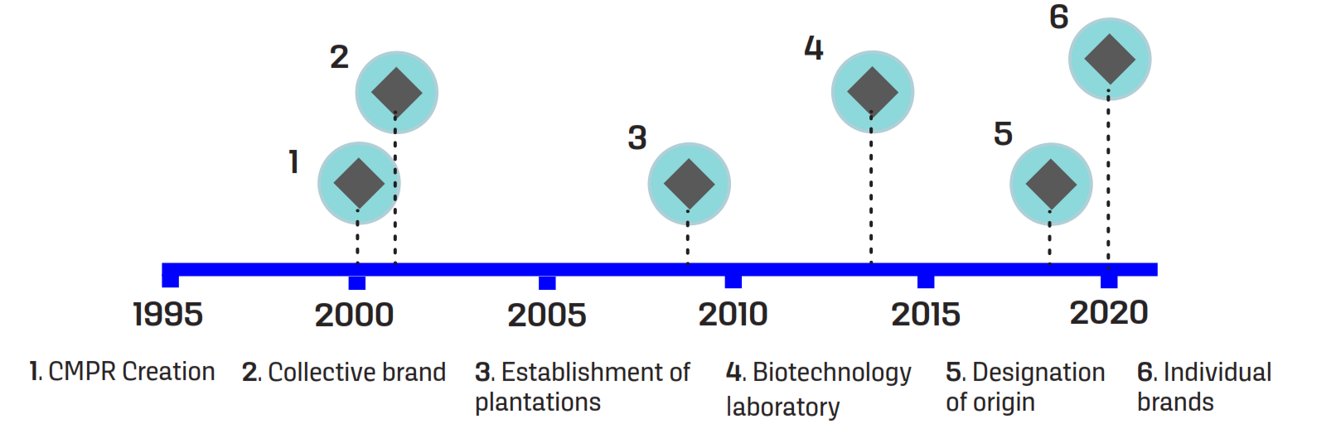
Source: Own elaboration.

Conclusions

This section must present, clearly and concisely, the key statements derived from the results and discussion. The conclusions should remain strictly within the scope of the study and must not constitute a summary of the results. Each conclusion must be directly aligned with the study’s objectives and hypotheses and should reflect only the findings that were empirically demonstrated. The inclusion of hypotheses, assumptions, or speculative interpretations is not permitted. Recommendations should be avoided unless explicitly stated as an objective of the research. This section must not include tables, figures, references, or citations. A maximum length of 400 words is recommended.

Acknowledgments
This section should include recognition of individuals, institutions, funding bodies, research grants, or any other entities that provided meaningful support or collaboration during the development of the study. To ensure a double-blind review, the authors' names should not be included.

Conflict of interest statement
Authors must disclose any conflicts of interest that could inappropriately influence or bias the outcomes of the study. In such cases, the following statement should be included:
The authors declare the following financial interests (or personal relationships) that could be considered potential conflicts of interest: [LIST CONFLICTS], which were addressed through [AGREEMENTS].

If no conflicts of interest exist, the authors should include the following declaration:
The authors declare that we have no known financial conflicts of interest or personal relationships that could have influenced the research presented in this article.

Declaration of Artificial Intelligence (AI) Use
If generative AI or AI-assisted technologies were used in the development of the manuscript, the authors must provide a brief description, for example:
During the preparation of this work, [NAME OF TOOL/SERVICE] was used for [REASON]. All material obtained with this technology was reviewed and edited, so the authors assume full responsibility for the content of the published article.

If generative AI or AI-assisted technologies have not been used, the authors must declare this; for example:
The authors declare that we have not used generative AI or AI-assisted technologies for the development of this manuscript.

The generation of results, discussions, conclusions, or the creation or modification of images in the manuscript using AI is forbidden.

References
All bibliographic references cited throughout the manuscript must be presented in accordance with APA 7th edition guidelines (http://www.apastyle.org). Make sure that all references cited in the text appear in the reference list, and all entries in the reference list are cited in the text. All references must include their DOI (Digital Object Identifier: www.doi.org) or, if unavailable, a direct URL where the source can be accessed. An APA 7 reference guide is available on the journal’s website.
All references must be from primary sources; references to secondary sources (i.e., “cited in”) are not accepted under any circumstances. Internet citations are not permitted, except when they refer to statistics or yearbooks published by official organizations; in such cases, the date of access must be provided. References should be current (last 10 years), and whenever possible, should represent 80 % or more of the total sources consulted.
If a reference management program is used, all field codes must be removed before submitting the manuscript:
- In your Word document, press Ctrl + e to select all content.
- Press Ctrl + 6 or Cmd + 6 to unlink all fields and remove hidden links.

Carbajal, B., & Partida, J. C. (2022, July 6). Berries, los frutos que ganan terreno en el campo mexicano. La Jornada. https://www.jornada.com.mx/2022/07/04/politica/004n1pol
Food and Agriculture Organization of the United Nations (FAO). (2022, July 13). Countries by commodity. FAOSTAT. https://www.fao.org/faostat/en/#rankings/countries_by_commodity_exports
González-Rivera, T. V., Martínez-Regino, R., García-Atra, L. J., & Dávila-Soto, J. M. (2023). The social and solidarity economy and the effectiveness of economic, social, and cultural rights. Textual, 84, 167-194. https://doi.org/10.5154.r.textual.2023.84.6
Infante-Gil, S., & Zárate-de Lara, G. (2012). Métodos estadísticos: Un enfoque interdisciplinario. Colegio de Postgraduados.
Instituto Nacional de Estadística y Geografía (INEGI). (2009). Prontuario de información geográfica municipal de los Estados Unidos Mexicanos. http://www3.inegi.org.mx/contenidos/app/mexicocifras/datos_geograficos/21/21164.pdf
SAS Institute, Inc. (2018). User’s guide (ver. 9) [software]. SAS Institute, Inc. https://www.sas.com/es_mx/home.html

